Business and Education Working and Learning Together
To Create a Better West Virginia

Join us

WVBEA and
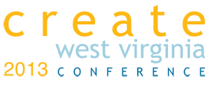
October 24, 25, and 26, 2013
Richwood, WV

$349--special rate for educators
Includes registration, meals and shuttle from Summersville to Richwood if needed

WVBEA members attend our joint fall conference with Create WV and learn with business leaders about present business issues. Bring that information back to your classroom and share with your students. Areas of sessions include Diversity, Quality of Place, Education, Technology, Entrepreneurship and Innovation. Lots of activities planned.

For more information and to register visit http://createwv.org/ or call or email Denise Stalnaker 304-642-2655 or denise.stalnaker@gmail.com

